Oluwafemi Micheal
  - My tech skill routine, my path way to success

Working with time

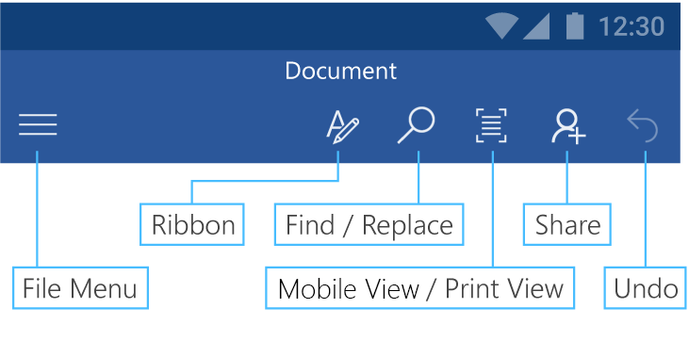
This tour introduces you to most of the buttons. They might be slightly different on your version of Android. Note that new features are constantly being released. Make sure you have all the latest updates in order to have all available features.

Easier reading on your phone
Switching to Mobile View makes it easier to read and edit on small screens.
Try it:
- Tap Mobile View. 
- Notice that the layout flows to fit your phone’s screen.
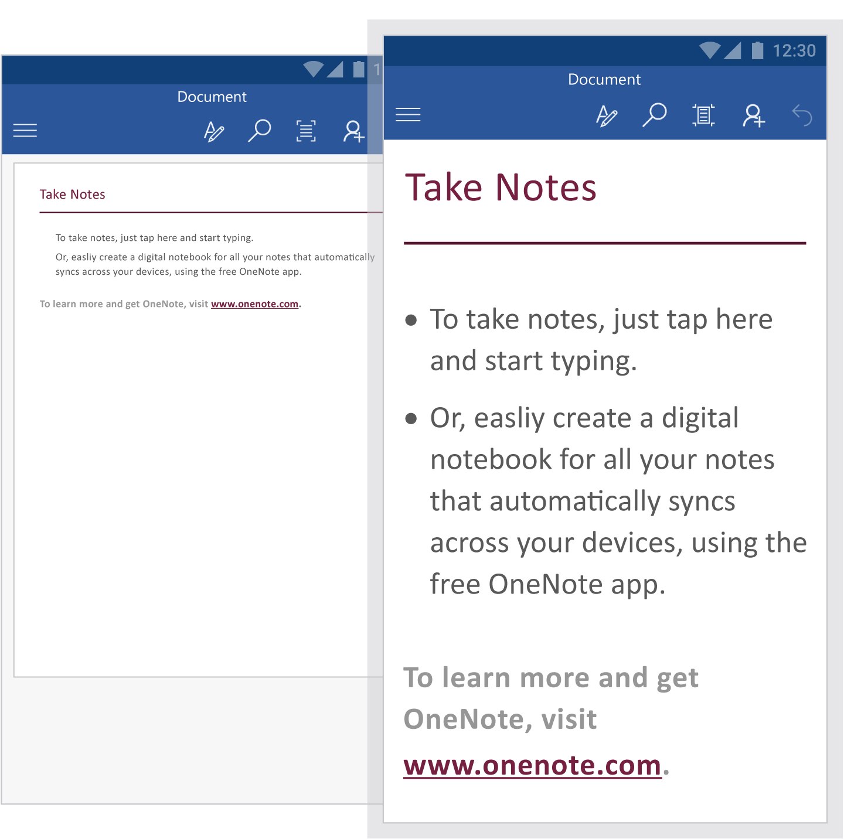
Keep in mind, if you want to switch back, you can just tap Print Layout. 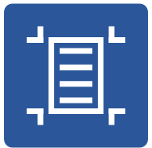

Save your way
Don’t worry, we’ve got your back. Your document automatically saves as you work so you don’t have to. If you ever want to turn Autosave off, it’s easy.
How it works:
- Go to the File menu 
- Pick Save and turn Autosave off.
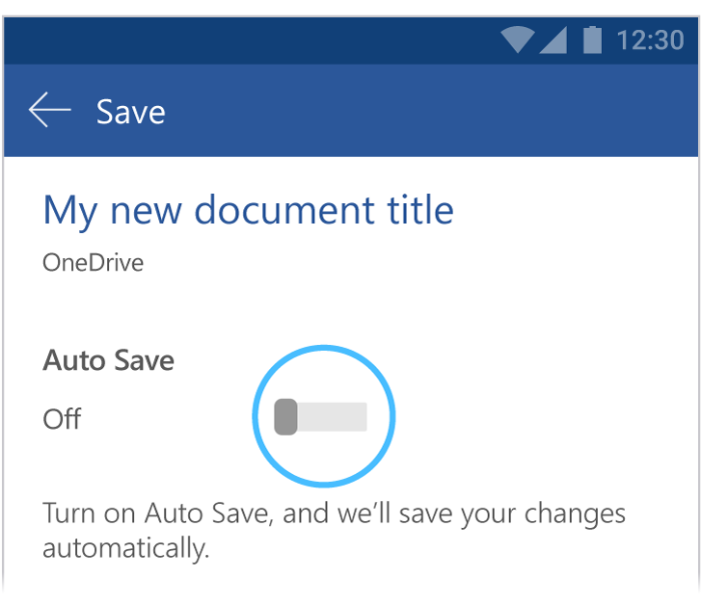
You can always go back to the File Menu for more document actions like Print and Share.

Add shapes
Insert a shape and add a color and text.
Try it:
- Tap the pencil to open the command ribbon. 
- Tap Insert > Shapes and add a circle.
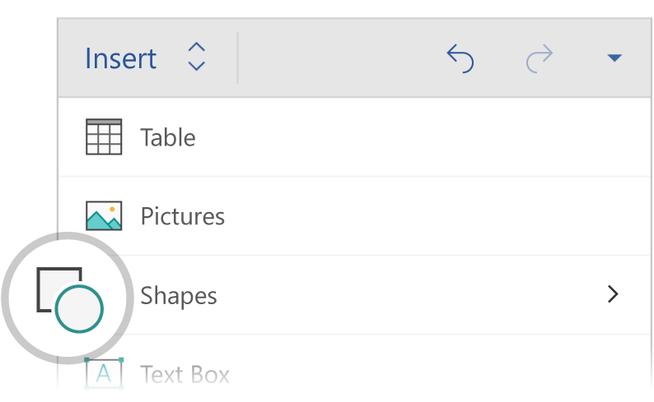
- Let’s change its color. Tap the circle, tap on the pencil and then select Shape > Fill and select a different color.
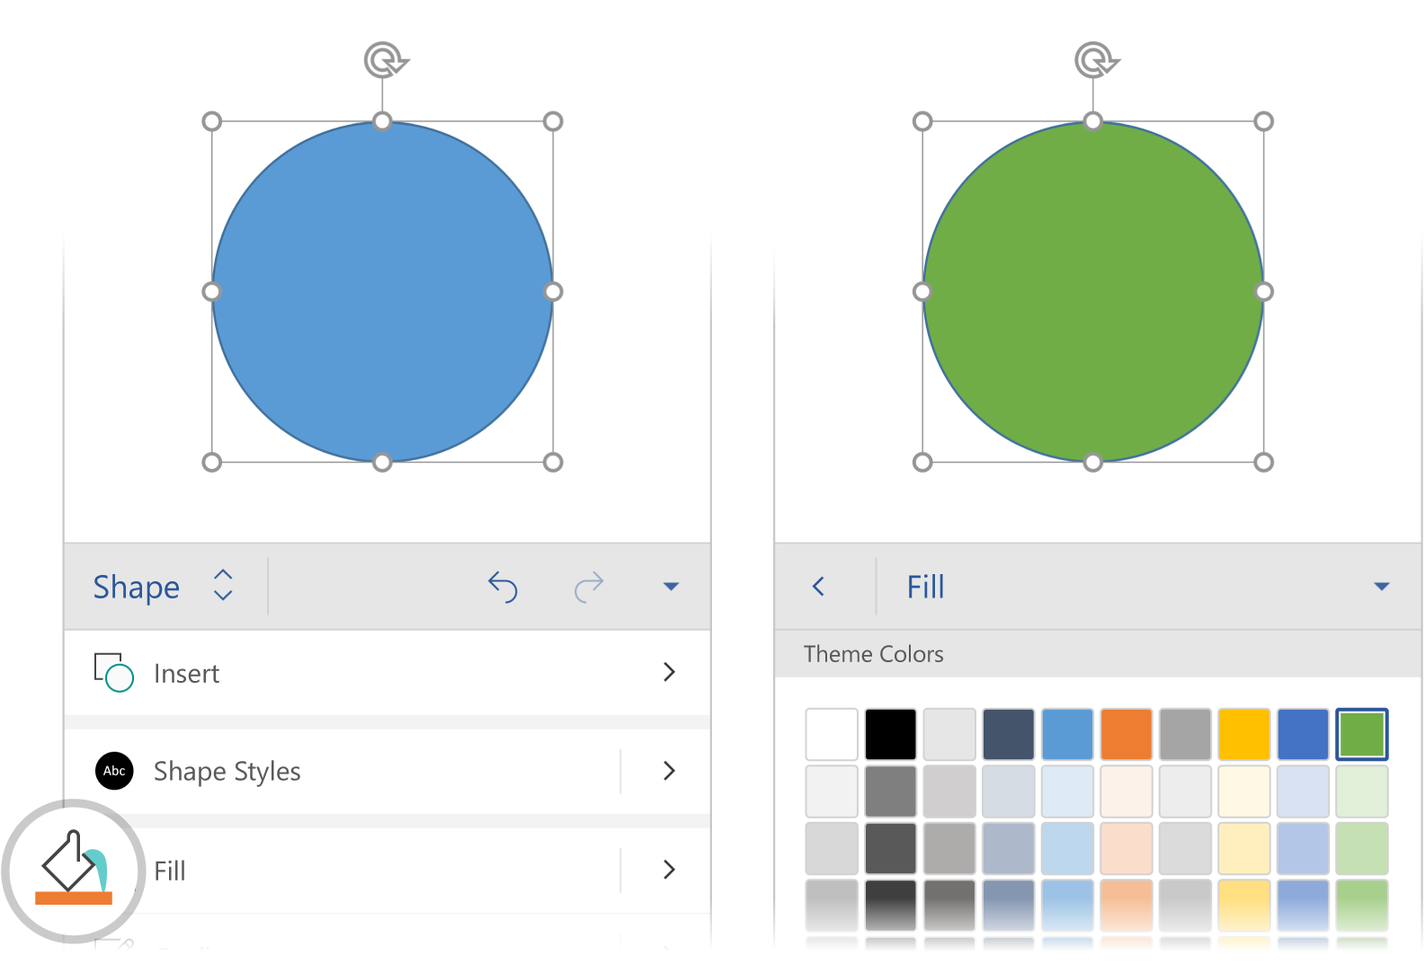
- For more options, tap Shape Styles and pick a look you like.
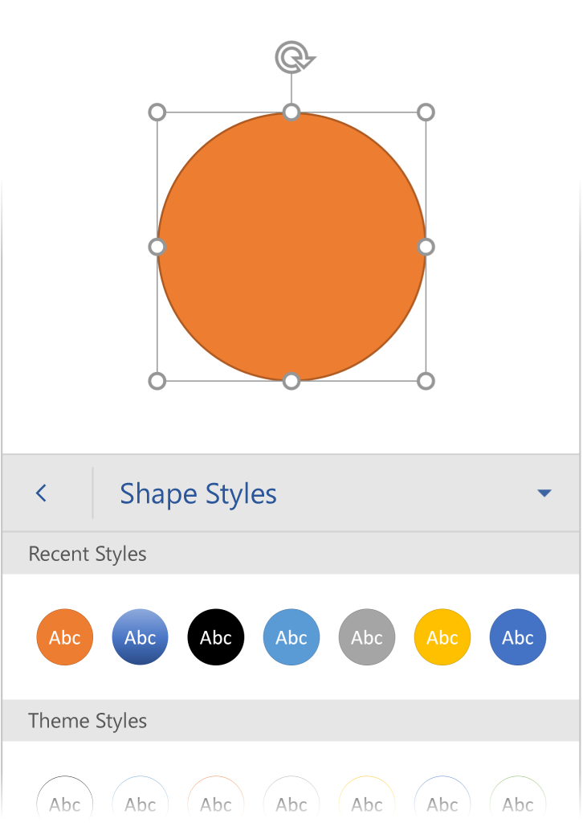

Work together
With your document stored online, your group can work on it together at the same time.
How it works:
- Save your document in an online location, like OneDrive.
- Tap Share. 
- Invite people, or send a link so they can edit with you.
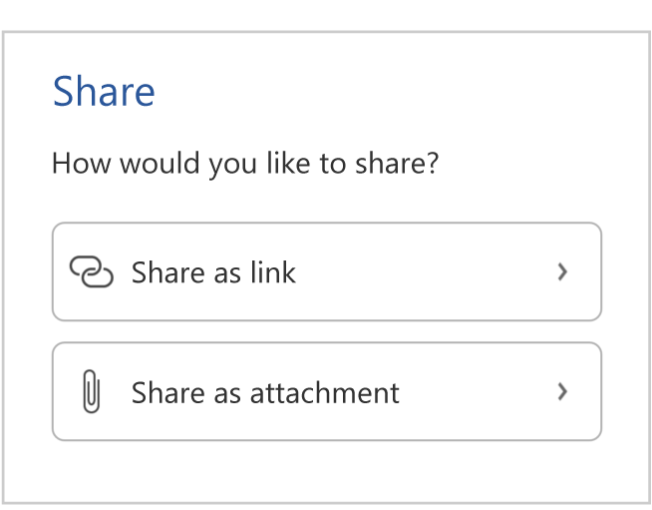

Smart Lookup
Smart Lookup brings research from Bing directly into Word.
Try it:
- Select the word “Hippos” in the following sentence: Hippos live in swamps
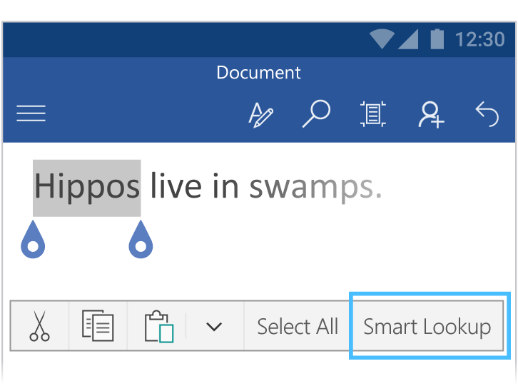
- Tap Smart Lookup and see info about hippos!
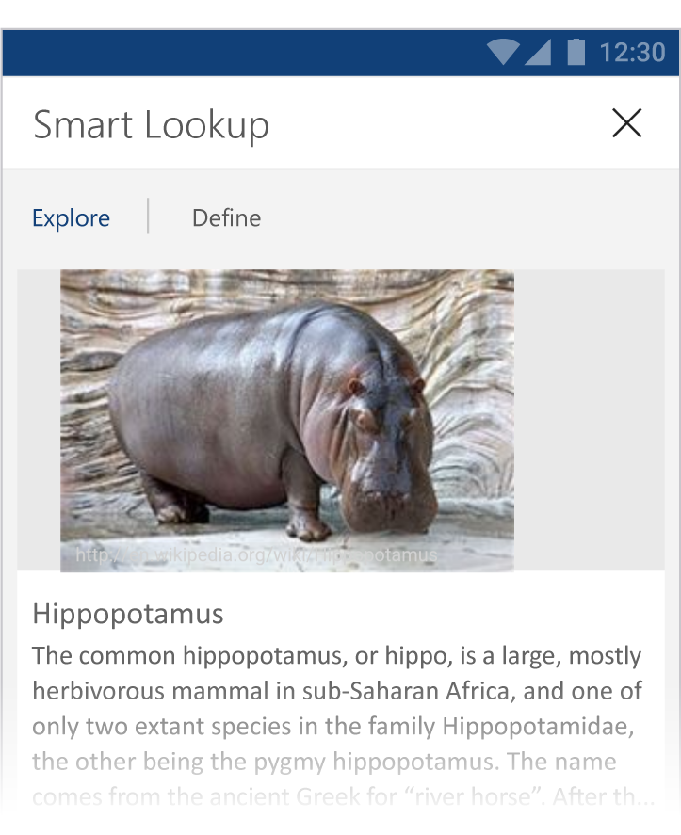
Source: Wikipedia CC-by-SA – https://en.wikipedia.org
- To close out of the Smart Lookup pane, tap the x at the top of the pane.
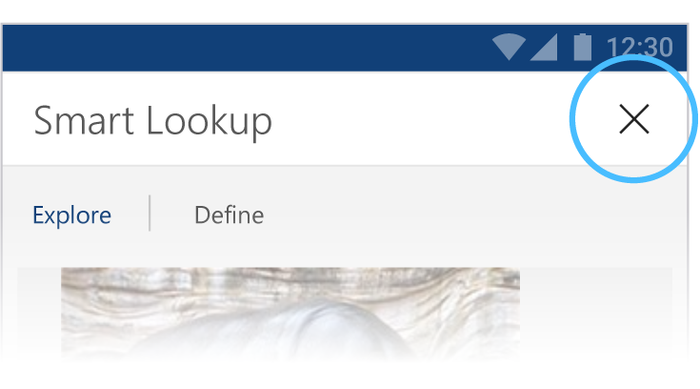

Comments
Commenting on a document is a great way to quickly add your feedback.
Try it:
- Tap somewhere in this paragraph, and then open the ribbon
- Choose Review > New Comment, and type something.
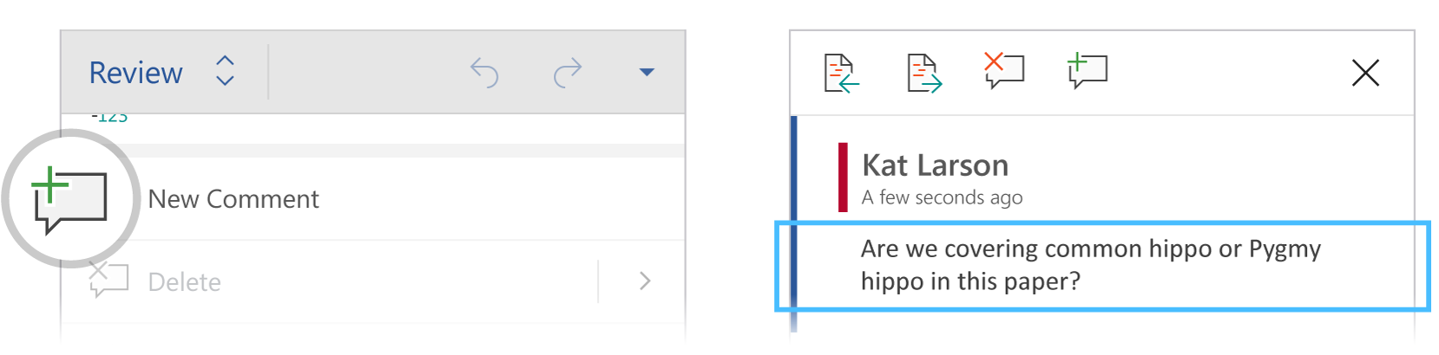
- Notice that your comment includes a Reply button. 
Use it to respond to a comment.
Hint: When you’ve taken care of feedback, get the comment out of your way without losing it by tapping Done.

More questions about Word?
Visit the Word team blog. 
Get help with Word for Android.

